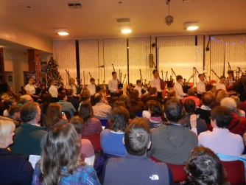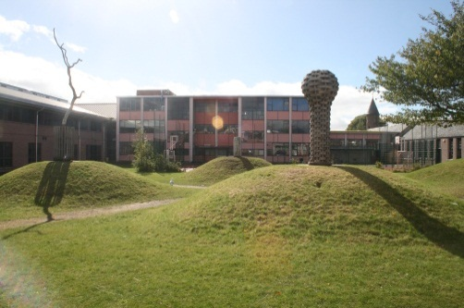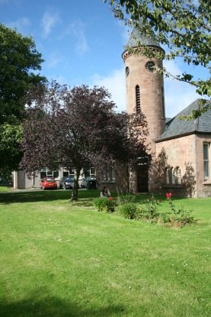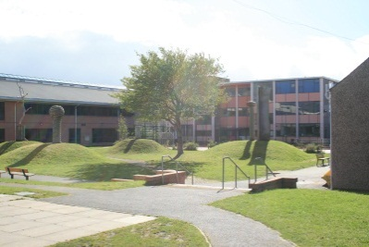

Your views matter to us and will help us to ensure that we offer a constantly improving level of service provision for our young people and for our community. We welcome your opinions and would ask you to share them with us regularly. You may receive questionnaires or be asked to complete an online survey and we endeavour to address any concerns or issues through our improvement plans.

Here are the steps if you wish to make a comment, compliment or complaint:

STEP 1 - Informally contacting us

• in person by appointment

• by email

• by telephoning

If you wish to let us know anything but do not initially need to come in to school please use the email or telephone contacts on the school website for the appropriate senior manager or member of Guidance/Pupil Support staff. Alternatively, you may contact the school office on 01381 620310 and a member of the office staff will be able to put you in touch with the most appropriate person.

You may also contact us in writing.

Step 1 would normally be used for the majority of comments, compliments or complaints.

STEP 2 - Formally contacting the Head Teacher

A formal complaints’ form is available on our website and should be used when you feel that the matter is of a very serious nature or where you feel a matter has not been resolved to your satisfaction. There is a link for the comments and complaints form on the website.

# Our Commitment to Improvement