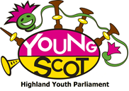

“Here We SMO Again!”
Highland Youth Parliament Conference
10th – 12th June 2015 – Sabhal Mor Ostaig, Skye
Report
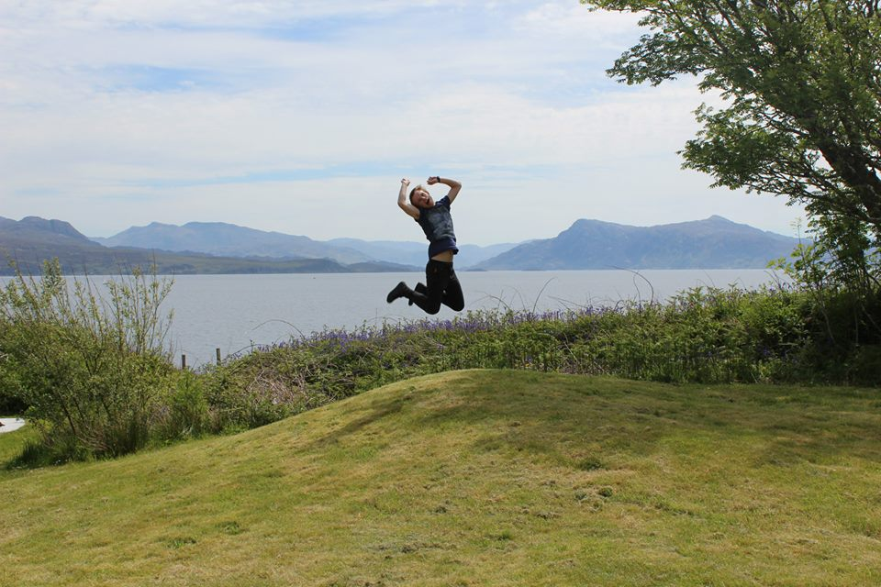

Youth Convener’s Comment
The following report is a summary of the most recent Highland Youth Parliament Conference which was held at Sabhal Mor Ostaig in Skye between 10th and 12th June 2015.
64 young people were in attendance over the 3 days to hear about, discuss and start work on some important issues. There was feedback and consultation with representatives from Highland Council’s Education Department, sessions from Scottish Fire & Rescue Service, Rape and Sexual Abuse Support Highland and many more.
This was my last conference as Highland Youth Convener and it was fantastic. There was a real buzz about the topics that were discussed and I am confident that the young people left to go back to their local areas engaged, energised and ready to campaign on issues that are important to themselves and the other young people in their local areas.
I would like to thank all the High Life Highland Youth Development Officers for their time and effort before and during conference, the Executive Committee for ensuring the conference ran smoothly (it really is young person led!) and finally all of the organisations who provided sessions or consulted with the Parliament.
I hope you enjoy this report and find it informative and interesting, I feel it highlights how engaged the Youth Parliament members are and that there are many important issues at the top of the Parliaments priorities.
Shaun Finlayson
Chair’s Comment
Sabhal Mor Ostaig has been a great place for our conferences to be held over the years. The conference saw the addition of many new members who were all eager to put forward ideas and quickly made friends with one another, which is always a good sign. The conference felt much livelier than the previous one, due to all members being able to attend from each forum and transport running smoothly.
The conference had a wide variety of themes this time instead of the normal set theme which I feel meant that we covered a lot more of the big issues facing local communities across The Highlands. These sessions ranged from talking to members of the Fire &Rescue Service to Anti-sectarianism. I feel that the members of HYP will have learned a lot from these great sessions and will make good use of it within their local areas.
Personally for me, the best part of the conference was seeing everyone getting involved together and everyone working along and making friends. A lot of new members arrived without knowing anyone, but come the last day they had all quickly made friends that they will keep in touch with for a very long time. Looking back to my very first conference, in 2012, I am still very close to those people I met back then, and I have loved getting to know every individual over the last few years.
Highland Youth Parliament allows members to learn about the problems that face everyone within the Highlands, and also allows them the chance to make a difference on such a wide scale.
Overall, this conference was a great success. I personally had a great time, and I am sure each and every member did as well.
Matthew Heaton

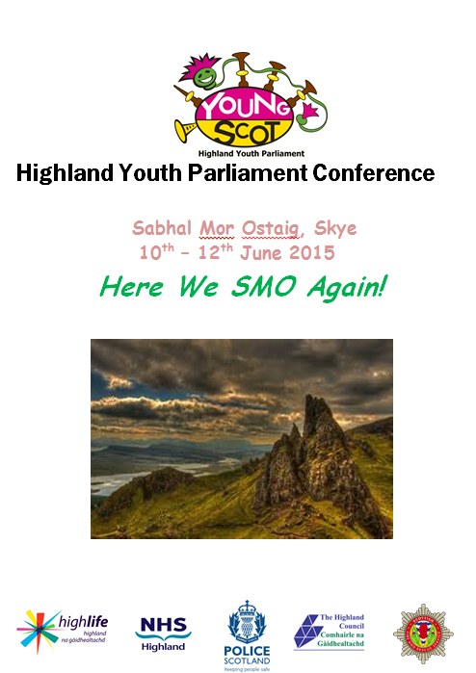
“Conference was really good and I enjoyed all of it!” – Hannah Earle, Inverness Royal Academy
Day 1 – Wednesday 10th June
“Let’s Get Started”
Once all the members arrived, got their badges, information packs and had lunch, it was straight to the hall to make a start on the day’s events.
Firstly, it was updates from the Xec Committee, the newly elected MSYP’s and the Youth Convener. This was a chance for everyone to hear what had been going on and a chance for the new members to get an idea of what keeps the Parliament ticking over.
The Scottish Fire and Rescue service started off the sessions for the first day of conference. This was a fantastic opportunity for young people to learn more about what the SFRS does and the role it plays in our communities. It was also a great chance for the service to consult with young people about the way it is perceived.
Following this, members engaged in an activity with RASASH (Rape and Sexual Abuse Service Highland) regarding sexual violence. Members were made aware of the different types of sexual violence and also what RASASH does to support survivors. RASASH also consulted with members about the accessibility of the organisation and how to make it as youth friendly as possible.
After dinner, the evening was topped off with a quiz, karaoke and a fancy dress disco!
“The Fire and Rescue Service session was well summarised, had good content and was positive, open and friendly.” – Oakley Cundall, Wick High
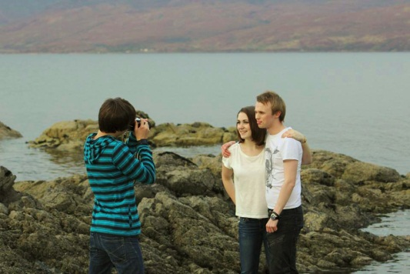
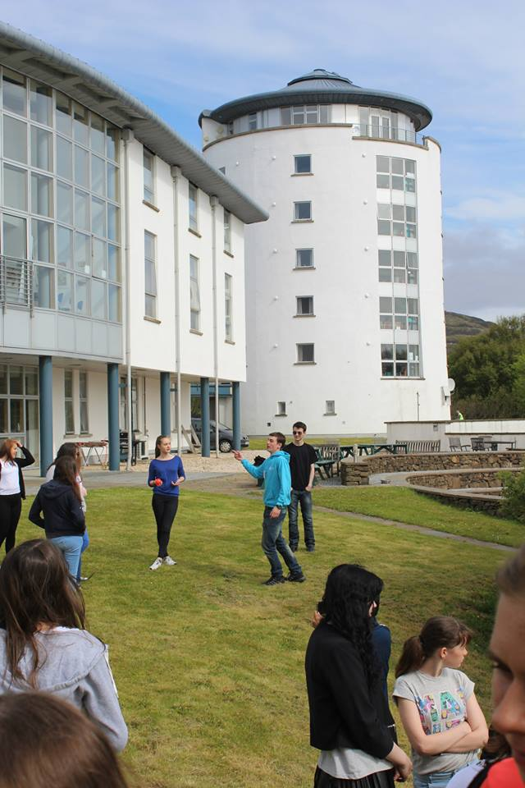
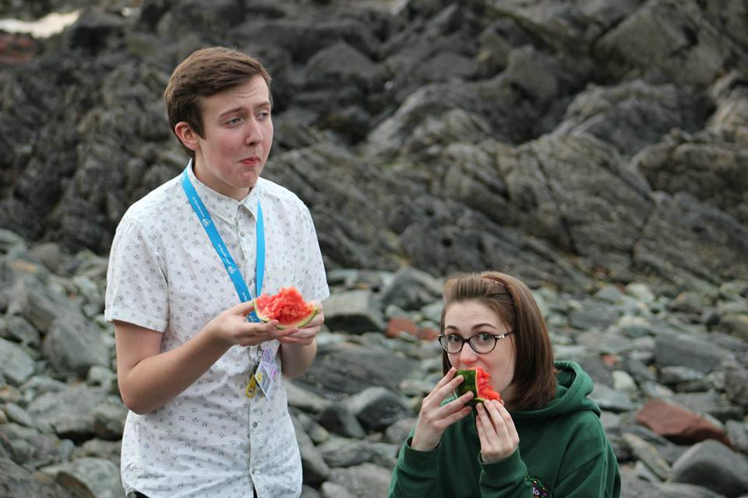

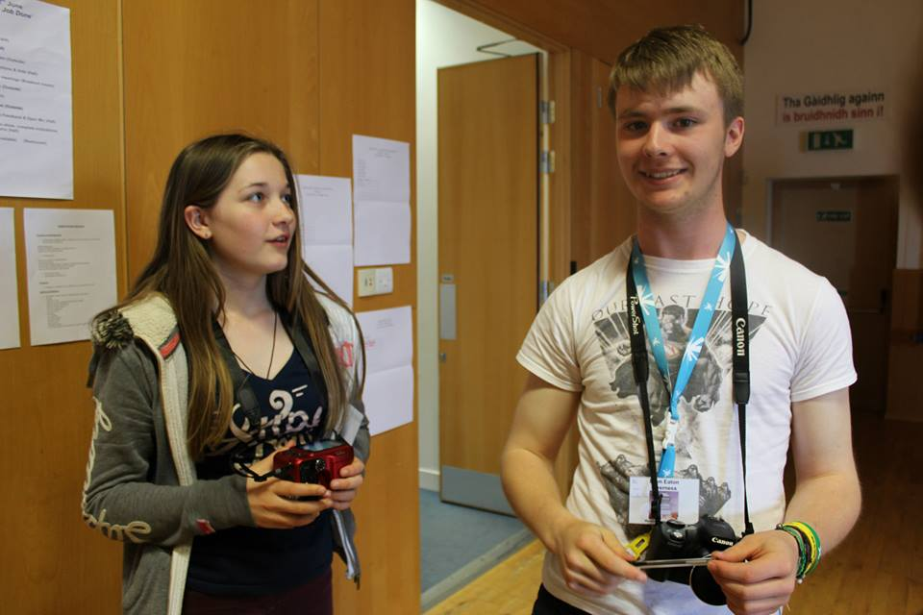
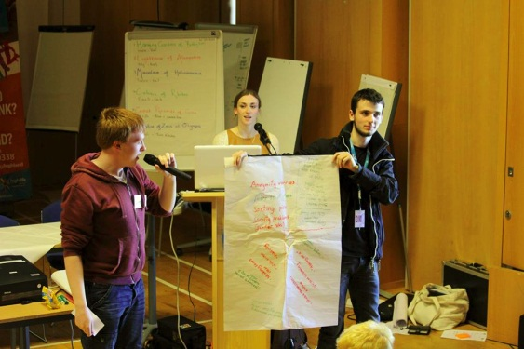

Session 2
‘Intro & Updates - Exec & Youth Convener Welcome, What it means to be a HYP member & SYP Intro’
Wednesday 10th June 2015 - 13:15 – 14:15
Facilitators:
Highland Youth Convener, HYP Chair and Vice Chair and Highland MSYPs
Workshop Purpose
To welcome and update HYP members, give information re Exec & Youth Convener activity, what it means to be a HYP member, to introduce the MSYPs and introduce HYP Subject Groups
Workshop Outcomes
- Members have been welcomed and updated on the above.
- Members have been updated on what the HYP Exec, HYP members and Youth Convener have been taking forward since the last conference
- Members are informed re what it means to be a HYP member
- Members are informed re who their new MSYPs are
- Members have the information they require to sign up to a subject group
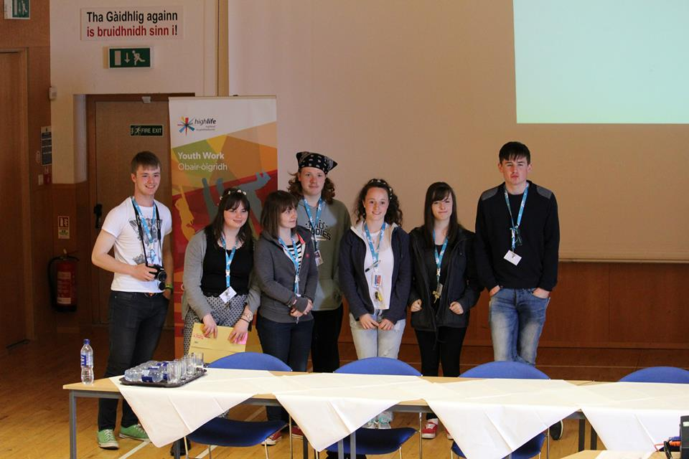
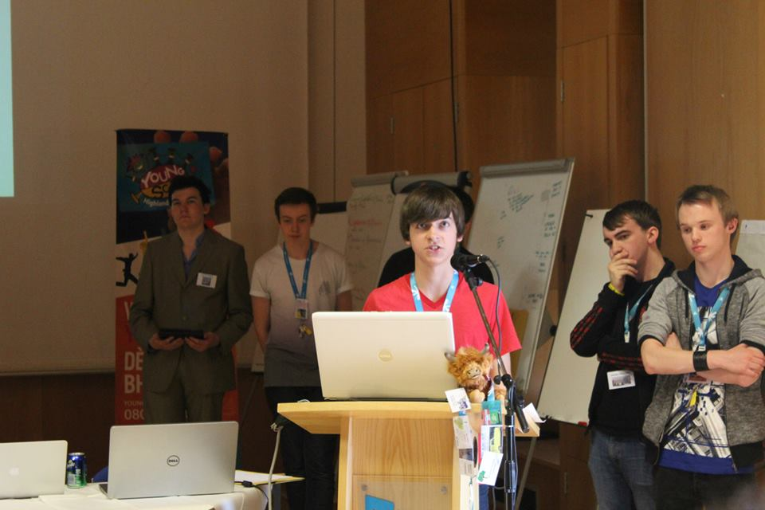

Session 3
‘Fire and Rescue Service Scotland Consultation’
Wednesday 10th June - 14:15-16:00
Facilitator: John Macdonald, Fire and Rescue Service Scotland
Workshop Purpose
- To have an open discussion where young people have the opportunity to raise general questions, issues and comments
- To inform young people of the FRSS and any service developments
- To receive young peoples’ views and ideas for improving safety in the home and communities
- To discuss young people’s views/perceptions of the Fire and Rescue Service and their ideas for future priorities
Workshop Outcomes
- Highland Youth Parliament members feel more informed re the Fire and Rescue Service Scotland and any developments or updates from their service
- HYP members have had the opportunity to discuss their views/make comments and ask questions
- HYP members’ views on the FRSS and safety in the home and communities is fed back to relevant meetings, committees or reports
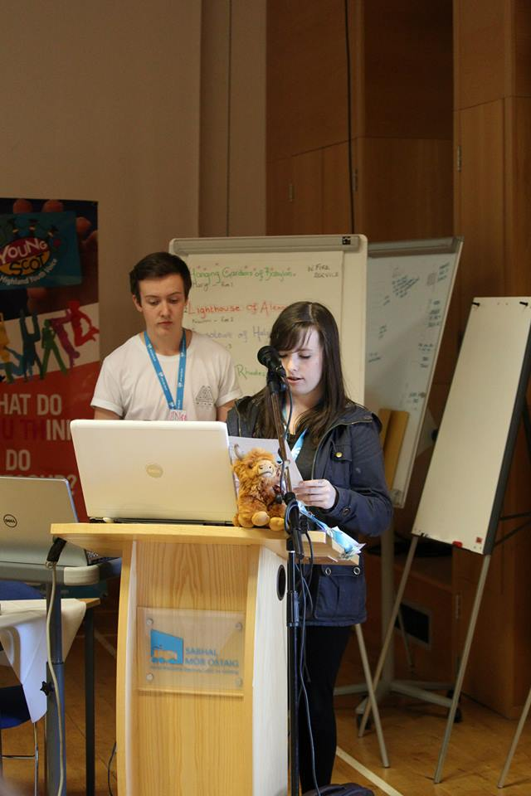
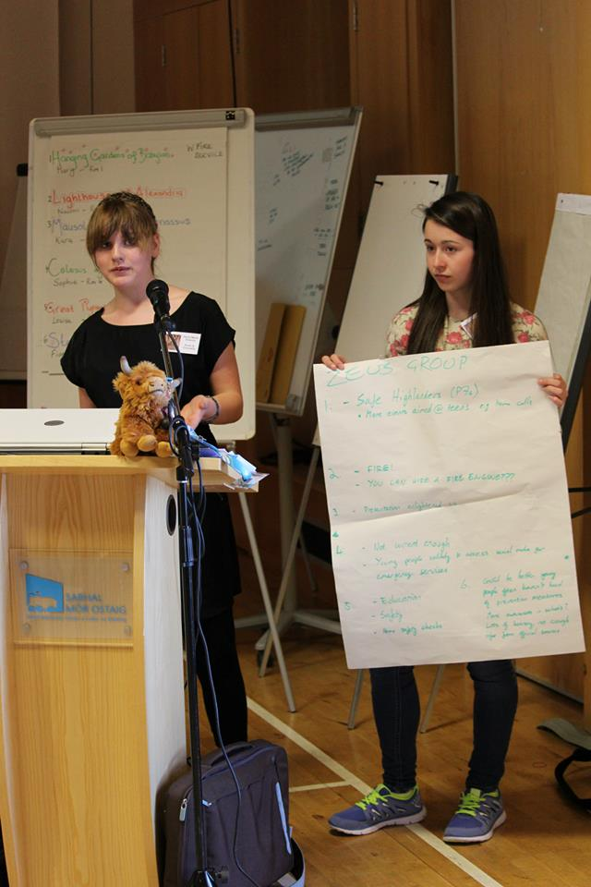
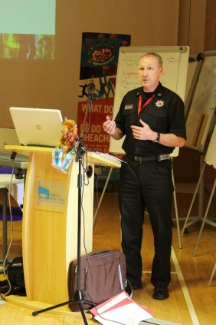
- Following the conference, HYP members pass on messages re the FRSS and safety in homes and communities in their local areas.

Session 4
‘Rape and Sexual Abuse Service Highland’
Wednesday 10th June - 16:00-18:00
Facilitator: Melody McIndoe
Outcomes
- Young people are more aware of the support services RASASH offers to survivors of sexual violence and their loved ones. They know RASASH supports anyone over the age of 13 and they know how to contact RASASH.
- Young people know of the work RASASH does with young people including prevention work with school/youth groups and the opportunities available through the Stand Up! RASASH project
- Young people have a better understanding of what sexual violence is, what the law says about consent and have an awareness as to the extent of problematic attitudes surrounding sexual violence/sexual bullying
- Young people are able to give their views on how to make RASASH as youth friendly as possible
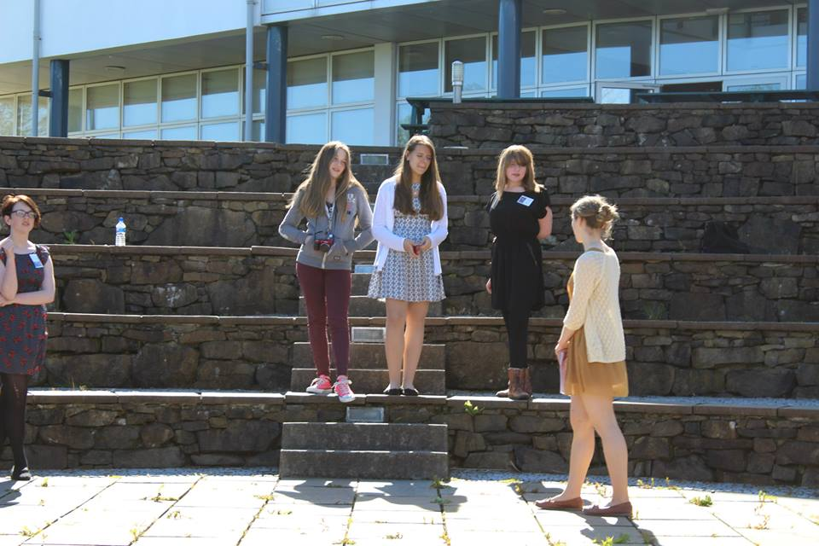
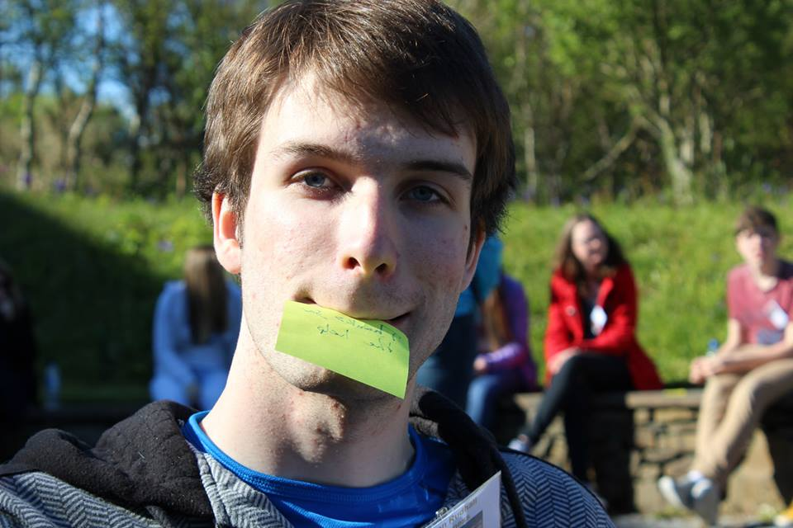
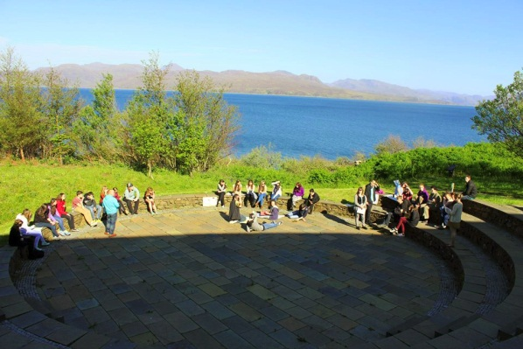

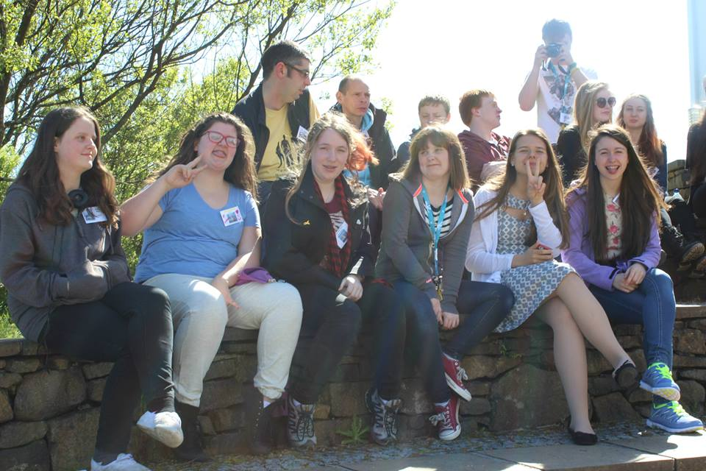
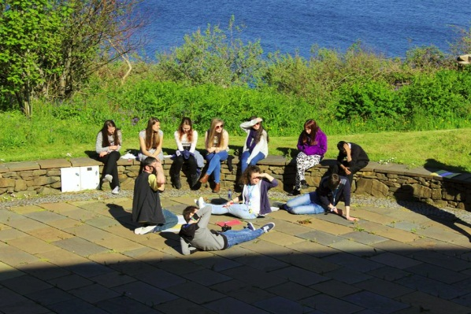
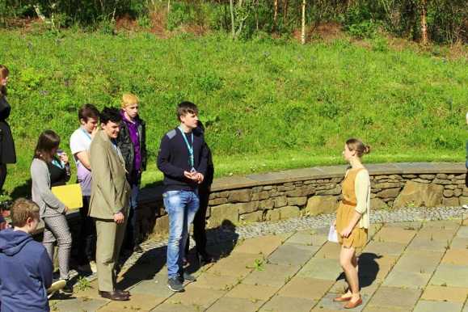

Evening Entertainment
There was a quiz at the start of the evening and then karaoke was the activity of choice, with members coming in some incredible fancy dress outfits!
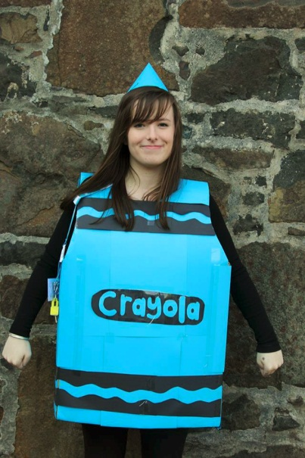
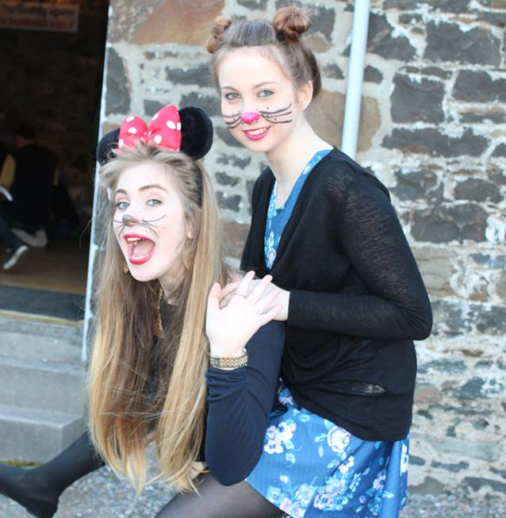

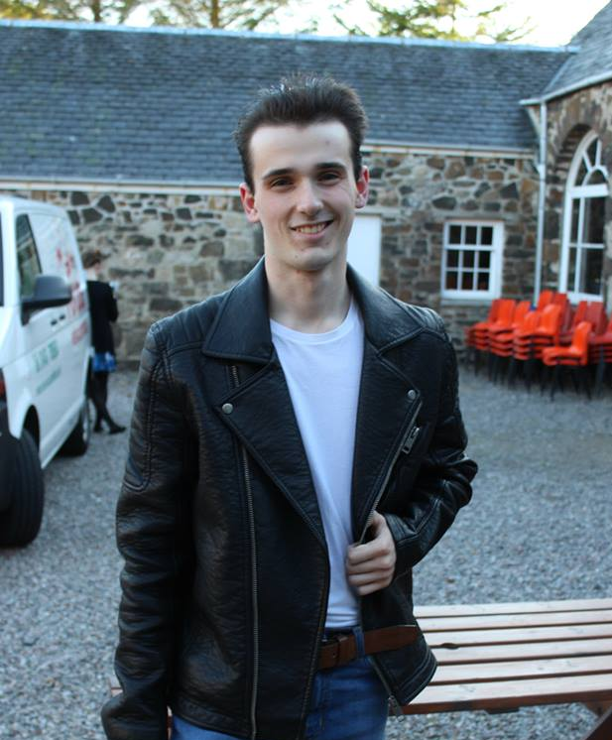
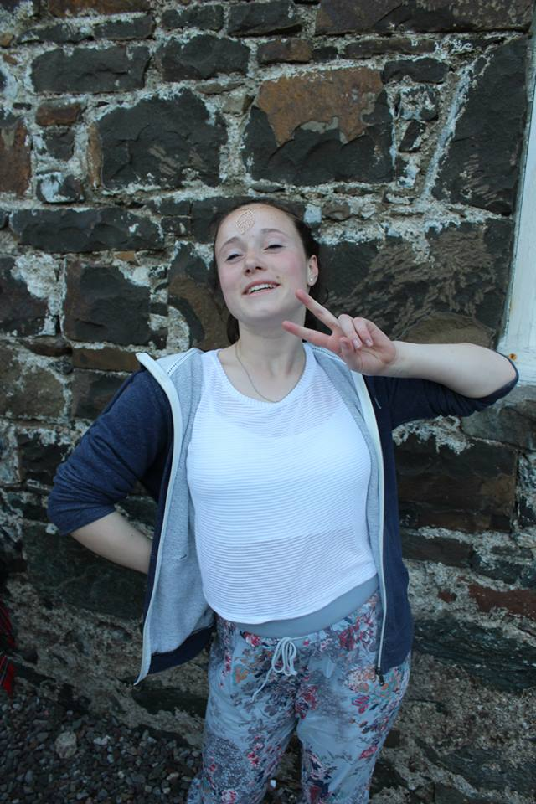
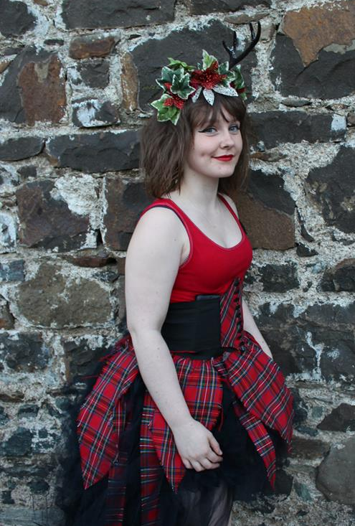
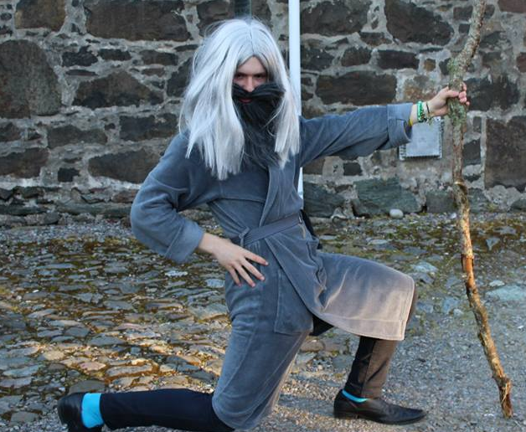
Day 2 Thursday 11th June
‘Making Progress’
Brodie Clark, the High Life Highland Youth Work in Sport Trainee started the day’s events off with an upbeat wake up activity. Sessions on the second day were from the Highland Council Education Service, SPEAK update, Anti-Sectarianism Project, Scottish Families Affected by Alcohol and Drugs and consultation and discussion in area groups.
There was also an extremely energetic Zumba session in the afternoon and a ceilidh in the evening!

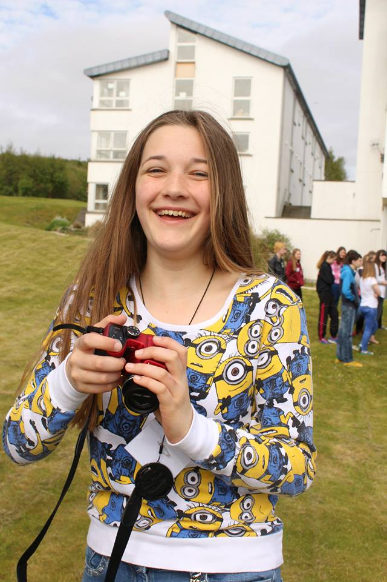
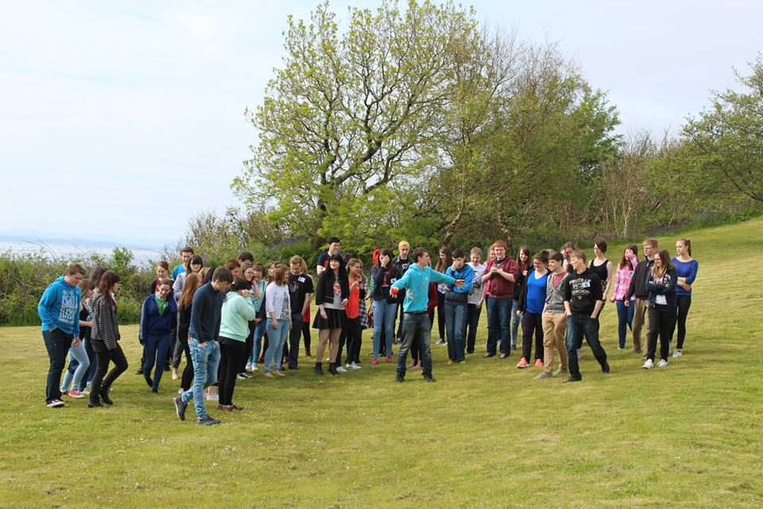

Session 5
‘Education Q&A’
Thursday 11th June - 10:30-12:00
Panel: Jim Steven, Head of Education, Don Esson, Quality Improvement Manager
Workshop Purpose
• To have an open discussion where young people have the opportunity to raise general education- related questions, issues and comments
• To inform young people of any Education service developments and consultations
• To receive young people’s views on current provision and proposals for the future
• To provide an update on any outcomes of the PSE curriculum consultation with HYP in Dec 2014
• To seek young people’s comments on the ‘Work placement’ and ‘Careers Education’ Standards from Education Scotland (Information in the email from Don Esson)
Workshop Outcomes
• Highland Youth Parliament members feel more informed re Education-related developments
• HYP members have had the opportunity to discuss their views/make comments and ask questions
• HYP members’ views on Education to be fed back to the ECAS Committee, Education Scotland and used in other relevant meetings or reports
“The Education session was informative, interesting and engaging and there was the opportunity to discuss and give opinions on a wide range of education topics. I learnt things about the system that I wouldn’t have known before and I will now share these with others in my school.” – Amandeep Kainth, Alness Academy
Session 6
‘Young People’s Mental Health – Update’
Thursday 11th June - 13:00-13:30
Speakers – Young people from SPEAK and Shaun Finlayson, Highland Youth Convener
Workshop Purpose
To enable SPEAK to give an update on how their project is developing and who they have been working with since the last HYP conference.
Workshop Outcomes
- SPEAK members have had the opportunity to raise awareness re their project
- SPEAK members have had an opportunity to increase their public speaking / confidence skills
- HYP members feel better informed re: SPEAK and how the project is developing and supporting young people in Highland
Session 7
‘Area Group Catch Ups’
Thursday 11th June - 13.30-14.00
‘Catch Up’ Purpose
- To provide an opportunity for members to have an informal catch up with staff and the rest of their area group – to check in with staff re any questions about the programme, sessions, accommodation etc.
- To develop area group communication
- To discuss the rest of the sessions on Thursday and Friday and to start thinking about their area group discussions/issues
Outcomes
- HYP members and YDOs get an opportunity to catch up and develop their relationships.
- To be better informed re: what will be happening next in the programme.
- To have started noting questions/issues for all of above.

Session 8
‘Anti-Sectarianism Project’
Thursday 11th June - 14.00-15.30
Facilitators - Karrie Marshall and Chris King, Creativity in Care
Workshop Plan
Introduction to the project developed by Brora Learning Centre (HLH) and Creativity In Care for the Scottish Government's Tackling Sectarianism work, followed by a hands-on peace-craft workshop. Followed by group discussion regarding ‘Peace’ and what it means to the members.
“Really put it into perspective how widespread and prevalent sectarianism is even in today’s society”- Ellena Leslie,Nairn Academy
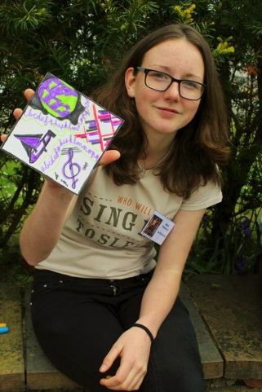
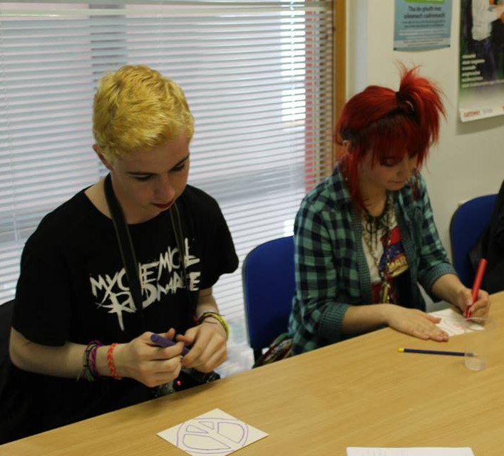

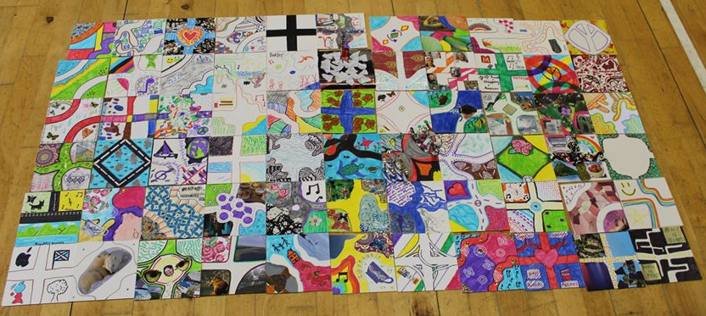

Zumba!
Members enjoyed an energetic Zumba session provided by Mo.

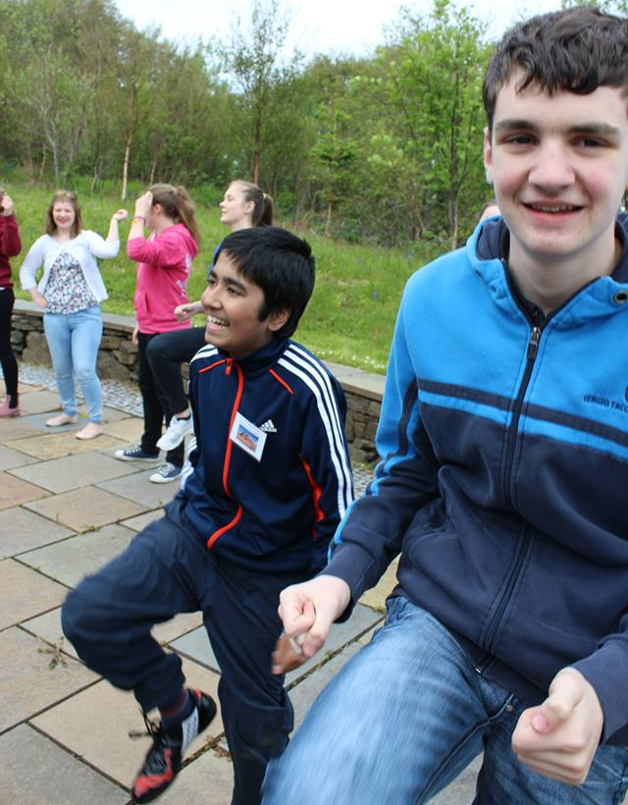
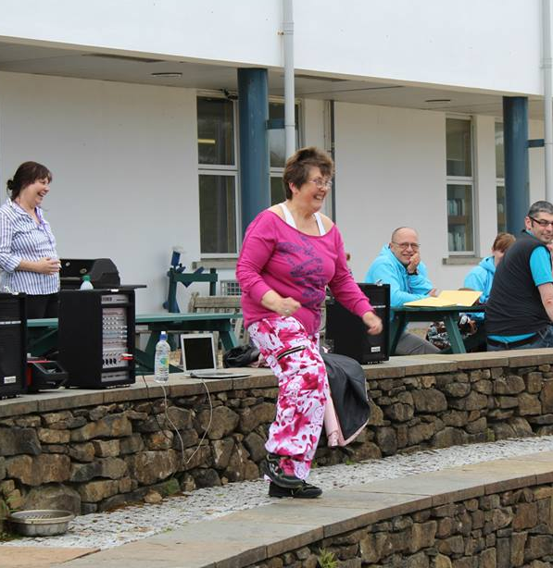

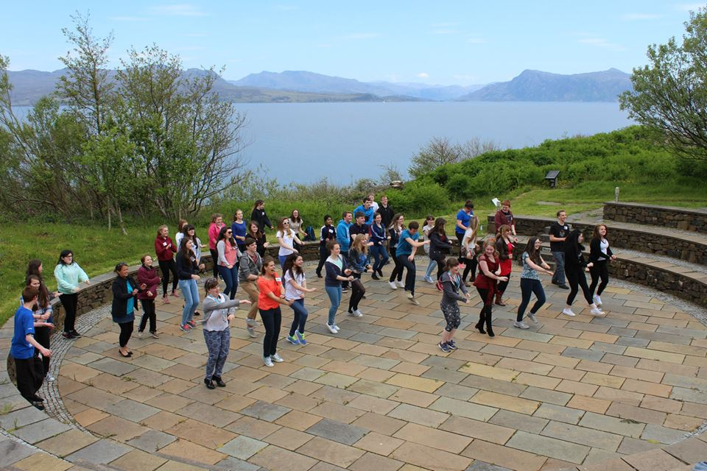

Session 9
‘Scottish Families Affected by Alcohol & Drugs’

Thursday 11th June - 17.10-18.10
Facilitators - John Holleran, Alcohol Liaison Officer
Workshop Purpose
- Highlight and explore the impact of substance use (Alcohol and Drugs) on those (other than the user) living in remote and rural locations.
- Develop a better understanding of the needs of family/communities affected by someone else’s use of alcohol or drugs.
Workshop Outcomes
- Introduce the issue of substance related
- Highlight stigma attached to substance use as a barrier to young people accessing support, advice and guidance in their own right
- Challenge social attitudes towards substance misuse
- Explore prevalence of problematic substance use
- Identify gaps/barriers to accessing support
- Help develop age-appropriate services and resources
- Develop solutions in an asset/strength-based approach
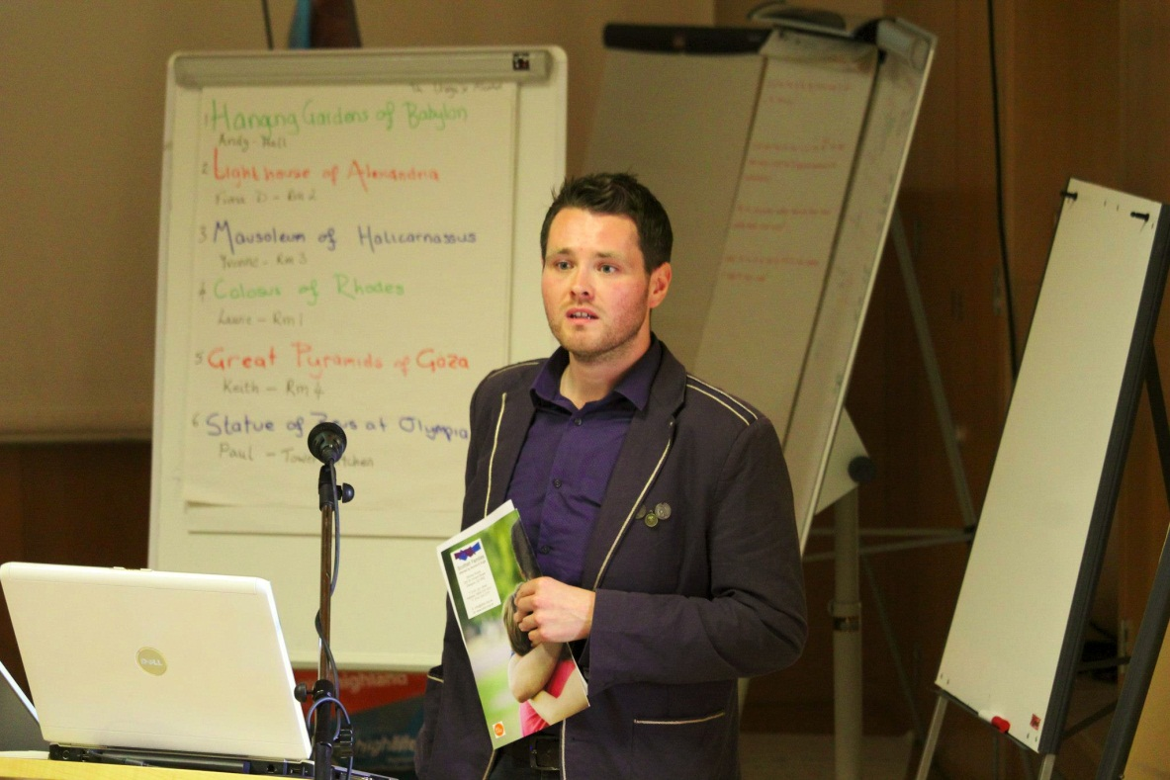

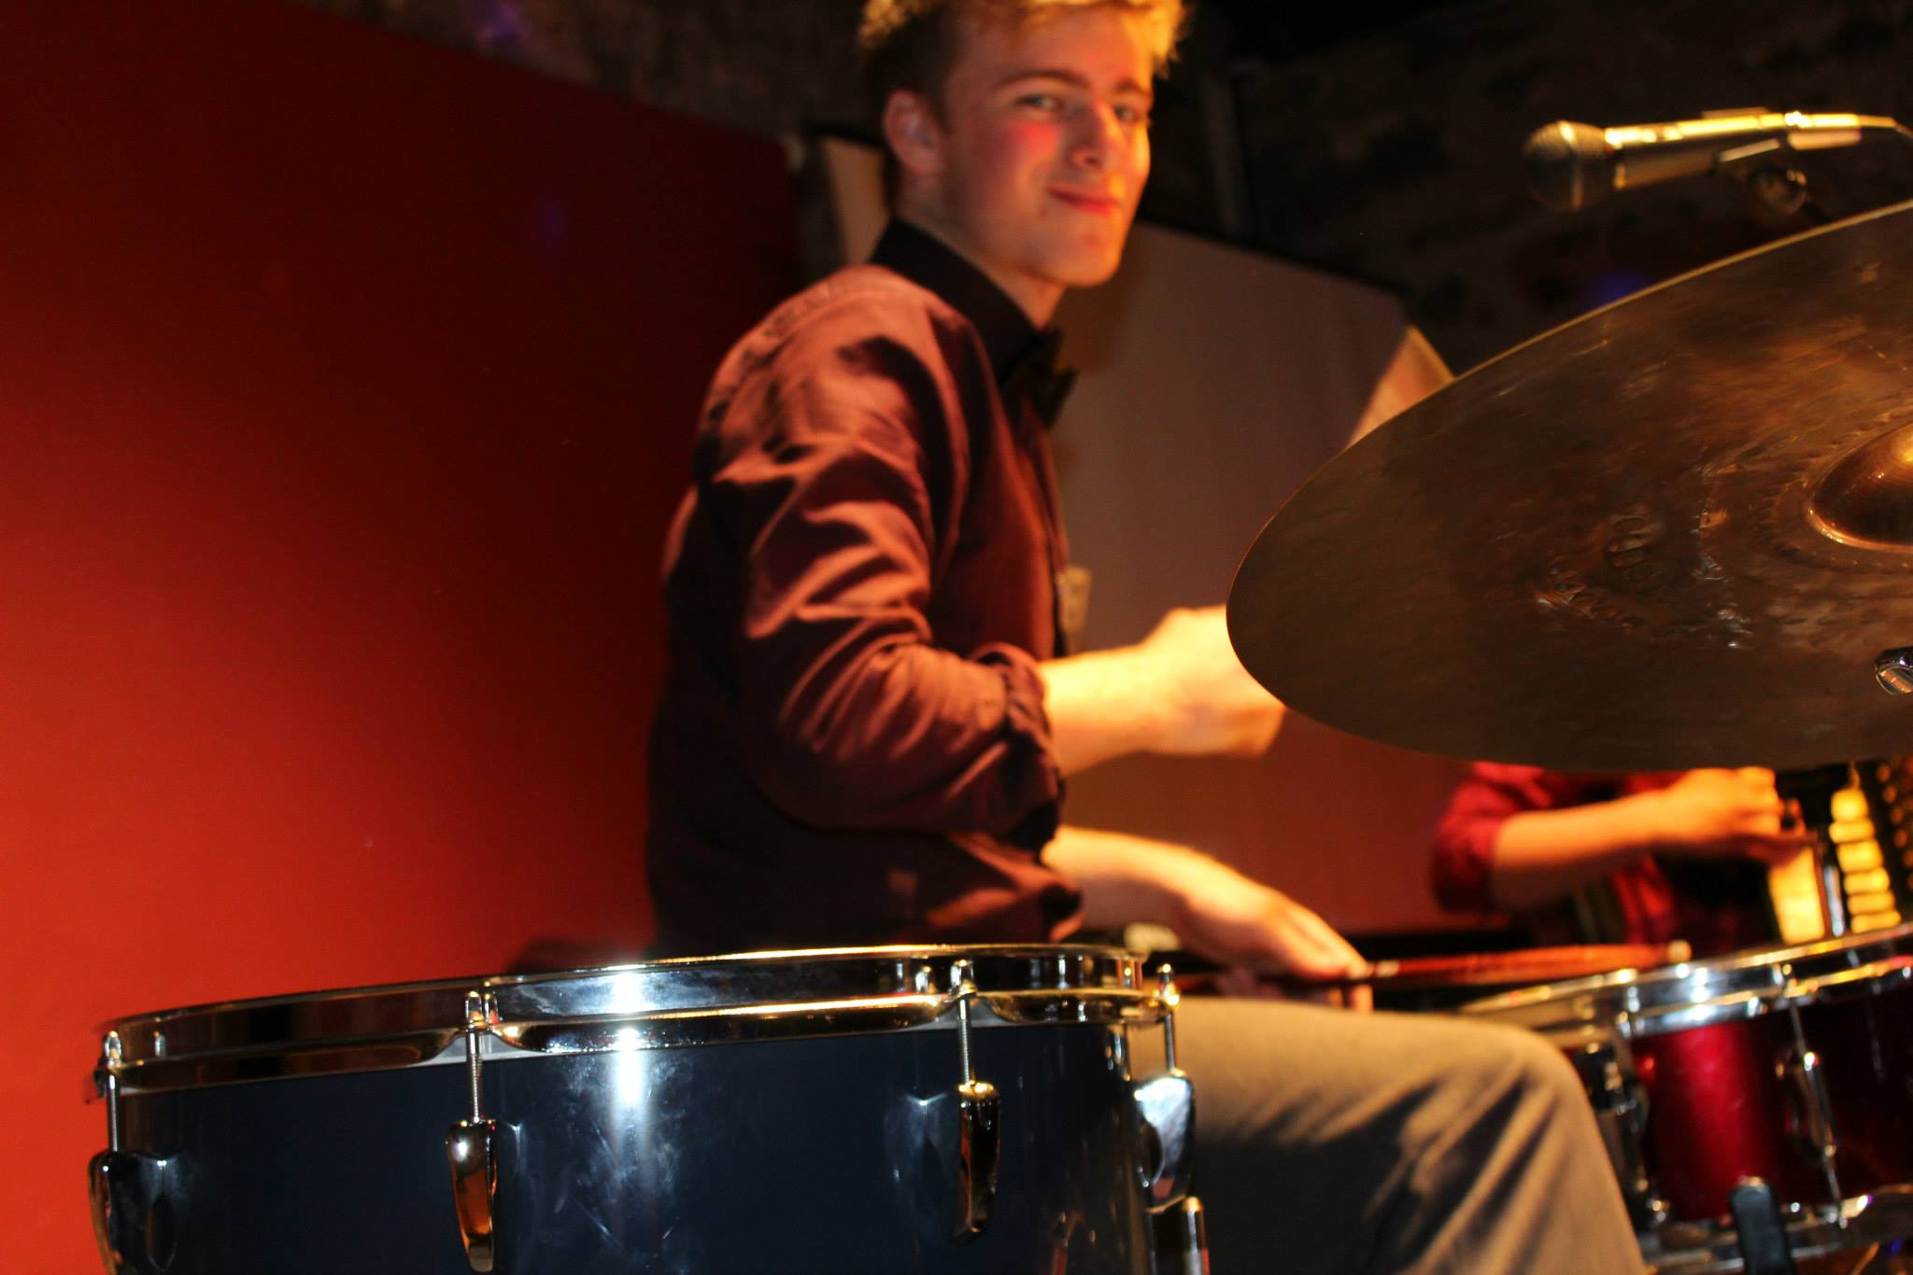
Evening Entertainment
‘The Raging Ceilidh Band’, who are pupils at Plockton High School, provided the music at the ceilidh for the evening. Members danced the night away including a Strip the Willow which lasted over an hour!

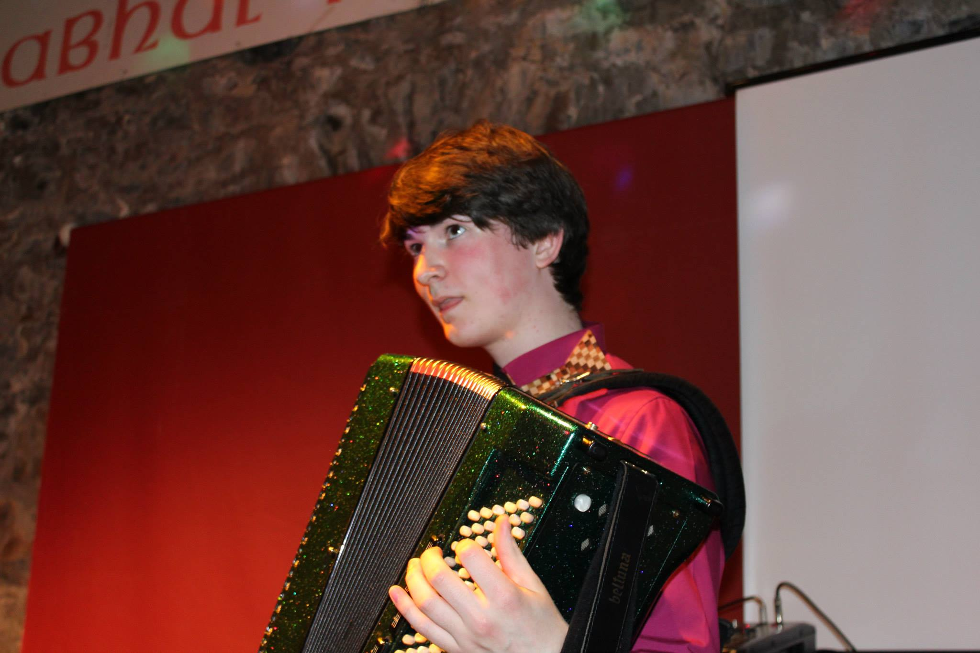

Day 3 Friday 12th June
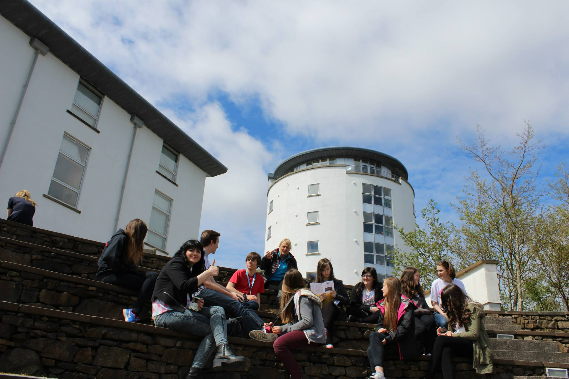
‘Getting The Job Done’
The final day of the conference played host to a session by the Highland Council’s ‘Carbon Clever’ team, local area group meetings to discuss local priorities and votes on 2 internal issues for the Youth Parliament. These votes were on MSYP involvement with Executive Committee and on Youth Forum structures. It was also a lovely, sunny day which allowed for plenty outside activities!

“I think conference went great this year and I really enjoyed the RASASH session as it made me more aware of sexual abuse in the Highlands” – Liam Bell, Culloden Academy

Session 10
‘Creating a Carbon CLEVER Highlands’
Facilitators - Gemma Cassells and Stephen Carr
Outline
The aim of this session is to engage the Youth Parliament members on issues surrounding climate change in the Highlands, to get their views on what a sustainable, low carbon vision for the Highlands looks like, and potential ideas using the ISM (Individual Social Material) model for how we would achieve this.
Activity 1: Agreement line (10-15 mins)
Set up physical or imaginary agreement line at the beginning of the session to get a feel for the participants’ general sense or engagement with climate change issues. Strongly agree at one end, strongly disagree at the other, starter questions or statements such as ‘football is brilliant’ can be used to demonstrate how the agreement line works.
Encourage individuals at different points along the line to explain why they chose their position.
Agreement line statements
- Climate change won’t really affect people.
- Everyone in the world is equally responsible for climate change.
- Everyone will be impacted by climate change in the same way.
- We need to do more about climate change
Main principles
- Fairness – the impacts of climate change will be felt worse by those who are poorest.
- Understanding of the issue – climate change is having an impact now and on people.
- Assessing the problem/motivation to act.
Why is it important to act sustainably/tackle climate change?
Include examples of current innovative projects to help generate ideas for Activity 2 – eg SolaRoad, Dutch data storage heating, smart grids, local food production etc.
Vision for the future – what will a low carbon Highlands look like in 2025?
Not being able to imagine a lower-carbon world is a huge impediment to designing and realising it.
It’s 2025. You’re back in the Highlands for a visit or for good, or maybe you’ve never left. You’ve maybe gone to university, started a career, moved home, moved away, come back for a visit. What does your house, your parent’s house, the street you live on, the town you shop in, and the community you are part of look, feel, sound and smell like?
Break into small groups with a volunteer leader who is briefed to facilitate discussions. Could start with a consequence diagram and then look to develop solutions (we could fill in some steps to provide prompts). Consider how we communicate, how we travel to work or school, how we travel to leisure activities, what we do for fun, what kind of houses we will live in and what kind of food we will eat.
Alternative to consequence diagram is to provide the starting point for mind maps, starting with a broad goal from one of the Carbon CLEVER themes ‘low carbon transport’ or ‘energy efficient homes’ or ‘sustainable jobs’ and then groups can fill in ideas, potential barriers, potential consequences.

Low emissions vehicles
Better battery technology
More charging points for EVs
Low carbon transport
People choosing active travel
Better walking and cycling facilities

“The Carbon Clever session was informative for both us and them. The session was both interesting and enjoyable. It allowed us to express our opinions on issues relating to ‘Carbon Clever’. All in all, a great session.” – Sean Currie, Dornoch Academy

Session 11
‘Local Forum Proposals and MSYP Involvement Vote’
Friday 12th June - 10.50-11.20
Facilitators - HYP Exec and Youth Convener
Background
There have been several issues raised by HYP reps and YDOs regarding the format of Local Youth Forums. These have included challenges due to the geography of certain areas, differences in characteristics of communities and the issues facing them within an area, and logistical problems with arranging area meetings.
These difficulties have led to some areas struggling to maintain an effective local ‘Area’ forum.
There have also been grey areas in regards to MSYPs holding Chair and Vice-Chair positions on the Executive Committee. This vote will formalise the situation and ensure it is representative of the Parliament’s opinion.
Workshop Purpose
In order to address the current challenges, HYP reps and YDOs are to be asked to consider the following proposals.
‘Local Youth Forums would be more effective if each ILC/High School catchment had its own Youth Forum’
‘MSYPs should be able to stand for the positions of Chair and Vice-Chair of HYP’
‘MSYPs should be able to vote in the elections for Chair and Vice-Chair of HYP’
Workshop Outcomes
HYP reps will have had the opportunity to consider the proposal and register the views of young people from their area via the electronic vote.
Results - The results were a majority voting in favour of changing the Youth Forum structure to allow a Youth Forum for each ILC and allowing MSYPs to stand and vote for the positions of Chair and Vice Chair on the Executive Committee.
Session 12
‘Local Area Groups’
Friday 12th June - 11.20-12.20
Facilitators - YDOs (role: To take notes and assist Exec to facilitate Area Groups)
Workshop Purpose
To allow Area Groups to:
- Review progress on previous Action Plan/campaigns
- Identify key local issues and prioritise
- Establish future Action Plan
- Nominate and vote in Exec reps where required
- Feed back to other HYP members (13.55-14.55)
- Launch Health Contacts Poster and add local details
- Discuss HYP school noticeboard and actions required
- Review and update Local Contacts Poster
Workshop Outcomes
- Local Action Plan for each Area Group produced.
- Area Groups to prepare to feed back to other HYP members on local progress and future action points
- Area Groups to have an update on local campaign themes
- Interim Exec reps elected
- Health Contacts and Local Contacts posters updated
- Action Plan for HYP school noticeboard produced

Session 13
‘Local Area Group Feedback & Open Mic’
Friday 12th June - 13.55-14.55
Facilitators - YDOs (role: To assist Exec to facilitate Area Groups)
Workshop Purpose
To allow Area Groups to feed back to other HYP members on:
- Key local issues/actions
- New Exec reps (where elected)
To allow HYP members to raise other points via ‘open mic’ session.
Workshop Outcomes
- HYP members to be better informed about other areas’ progress and future action points, and Interim Exec reps where elected.
- Members to have had an opportunity to raise other comments
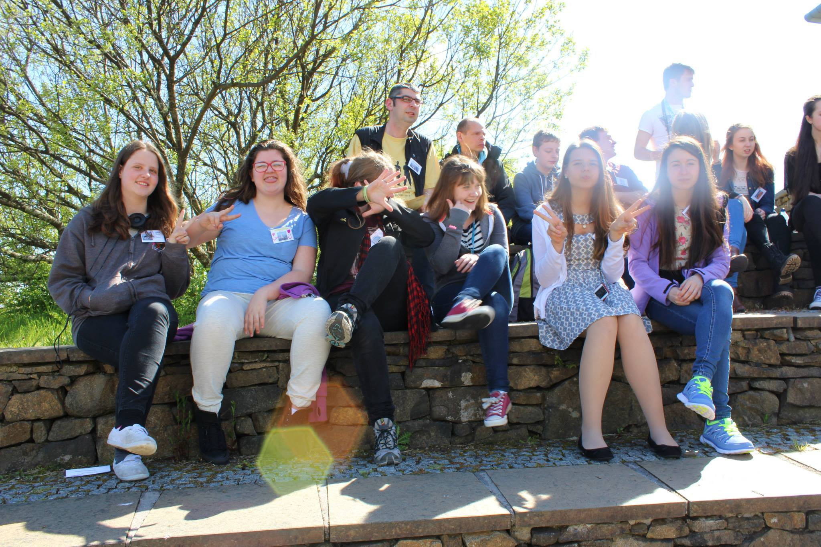

What Next?
The views expressed during consultation sessions are all fed back to the people or organisations that have a direct involvement with the issues. One of issues that have come out of this conference is Peer Mentoring, whether that is for general situations or for mental health. It has been discussed that many young people lack the skills to help their peers cope with mental health problems and the Parliament thinks peer mentoring would go a long way in supporting young people who are going through difficult times. The Highland Council’s Education Department will be looking at ways of engaging young people through an Improvement Group which would feed into the Council’s ‘Schools Improvement Group’. Many young people also expressed a strong desire to work closely with organisations such as RASASH and Scottish Families Affected by Alcohol and Drugs. They felt that awareness raising initiatives in schools or local Youth Forums would be a great way to engage and educate more young people.
Due to the results of the Area Youth Forum vote, each High School catchment area will now have their own Youth Forum. This can allow for more locally focused campaigns and the HYP members can meet up when it suits them to discuss area wide issues.
Contact Details
For more information, please contact the High Life Highland Youth Services team.
Phone – 01463 663812
Shaun Finlayson – youth.convener@highlifehighland.com
Audrey Anthoney – Audrey.anthoney@highlifehighland.com
Ian Abbott – ian.abbot@highlifehighland.com
“It’s great to see so many like-minded young people working hard to make a difference” – Mikey Harris, Kinlochleven High

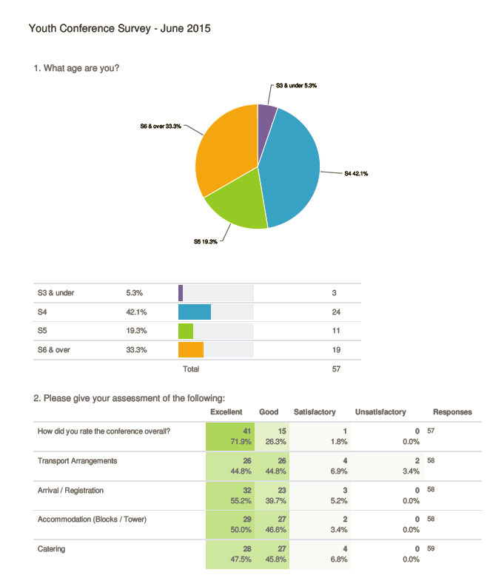

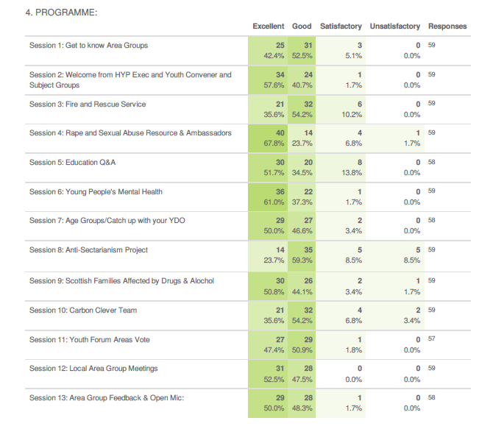
fff

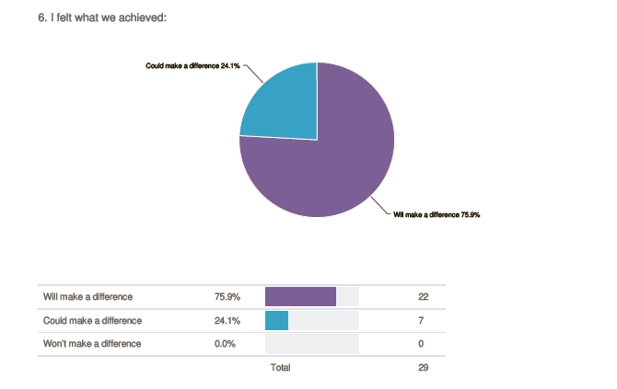

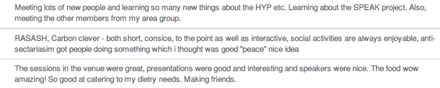
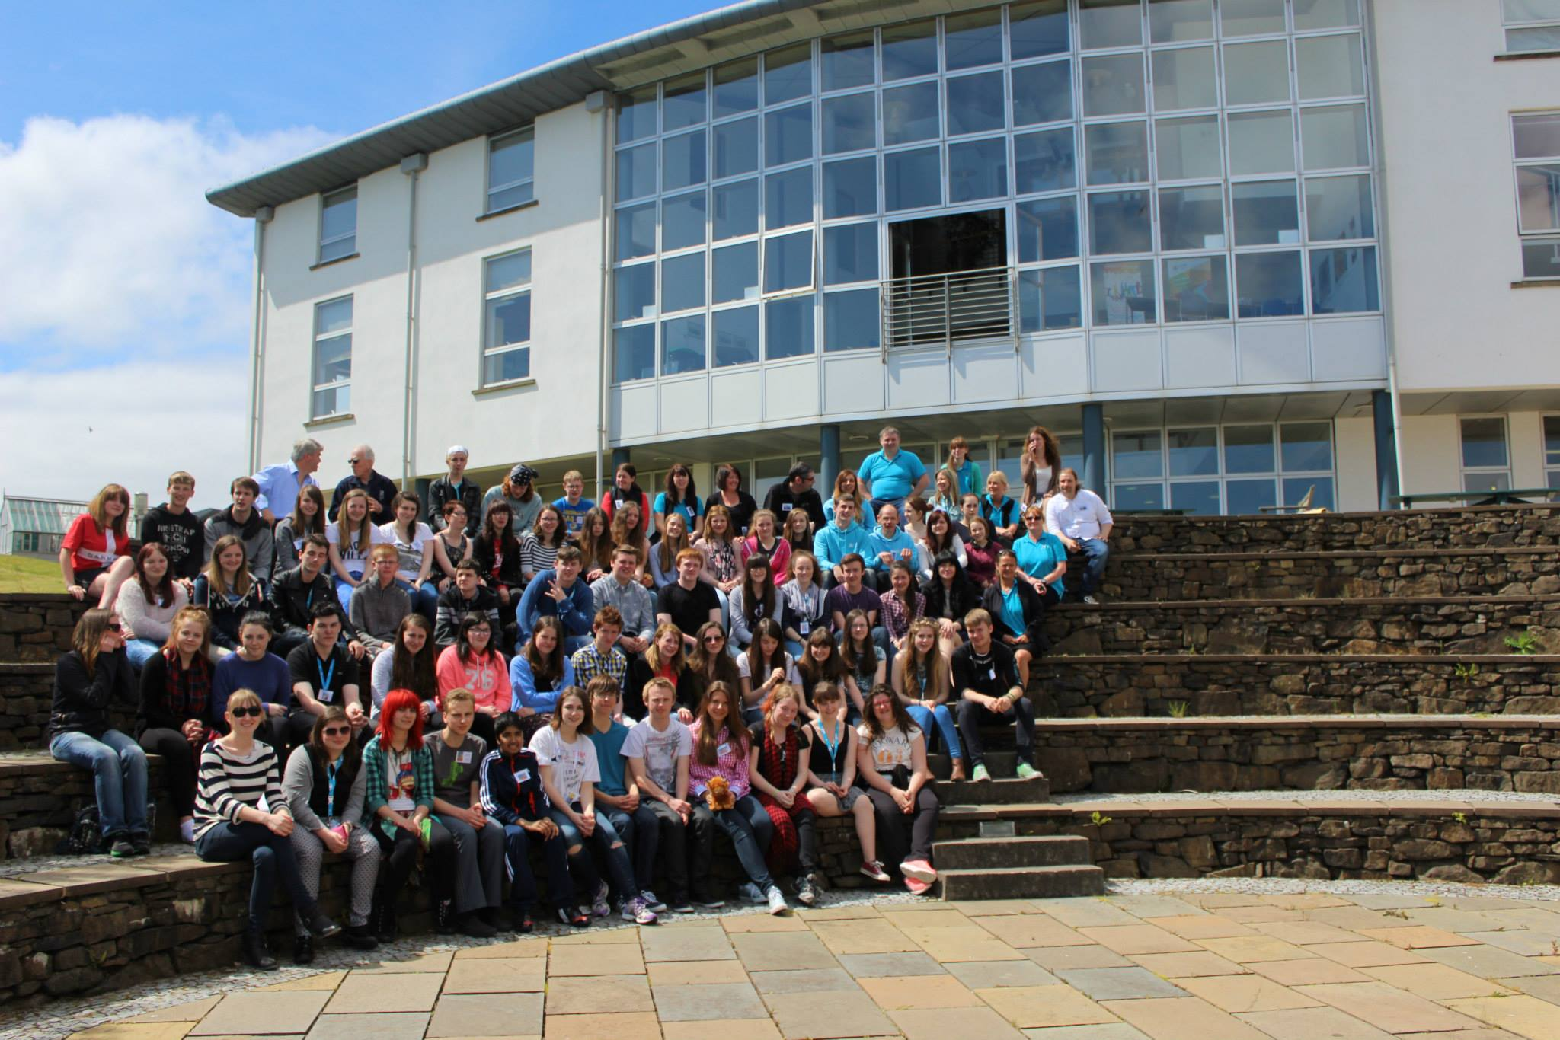
Group Photo!

